**Steps To Create G-Drive Credentials and Connect to tGoogle Drive component**

Step 1:- open the Google Drive

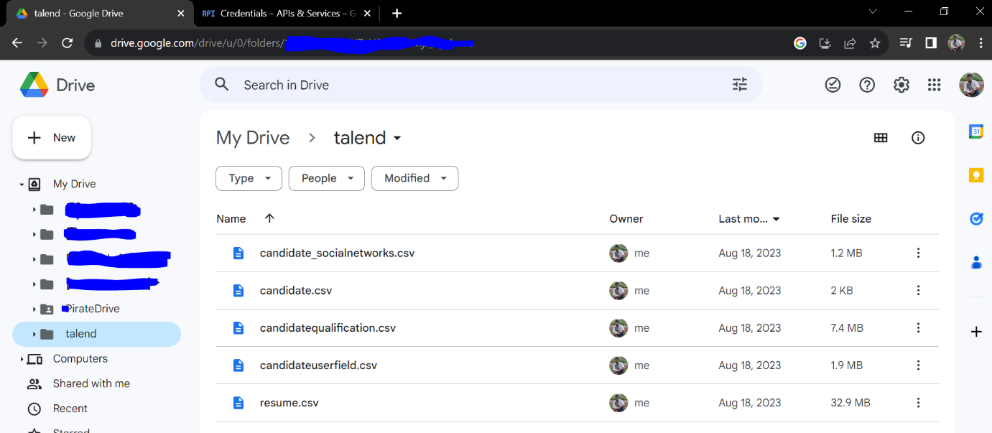

Step 2:-login to the Google cloud

(Creation of Client Id & Client Secretkey for Oauth)

<https://console.cloud.google.com/>

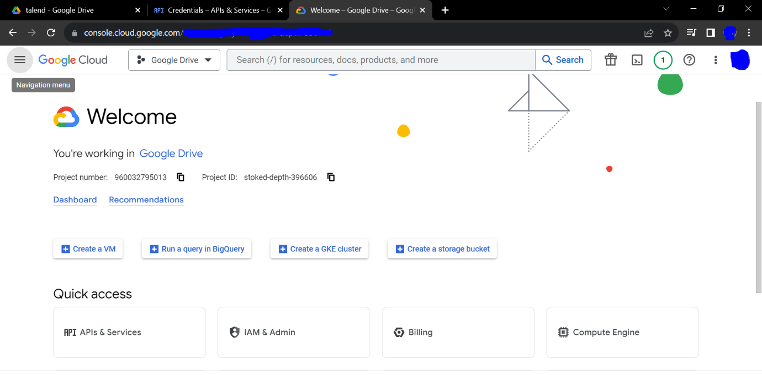

a:- Click on API and Services.

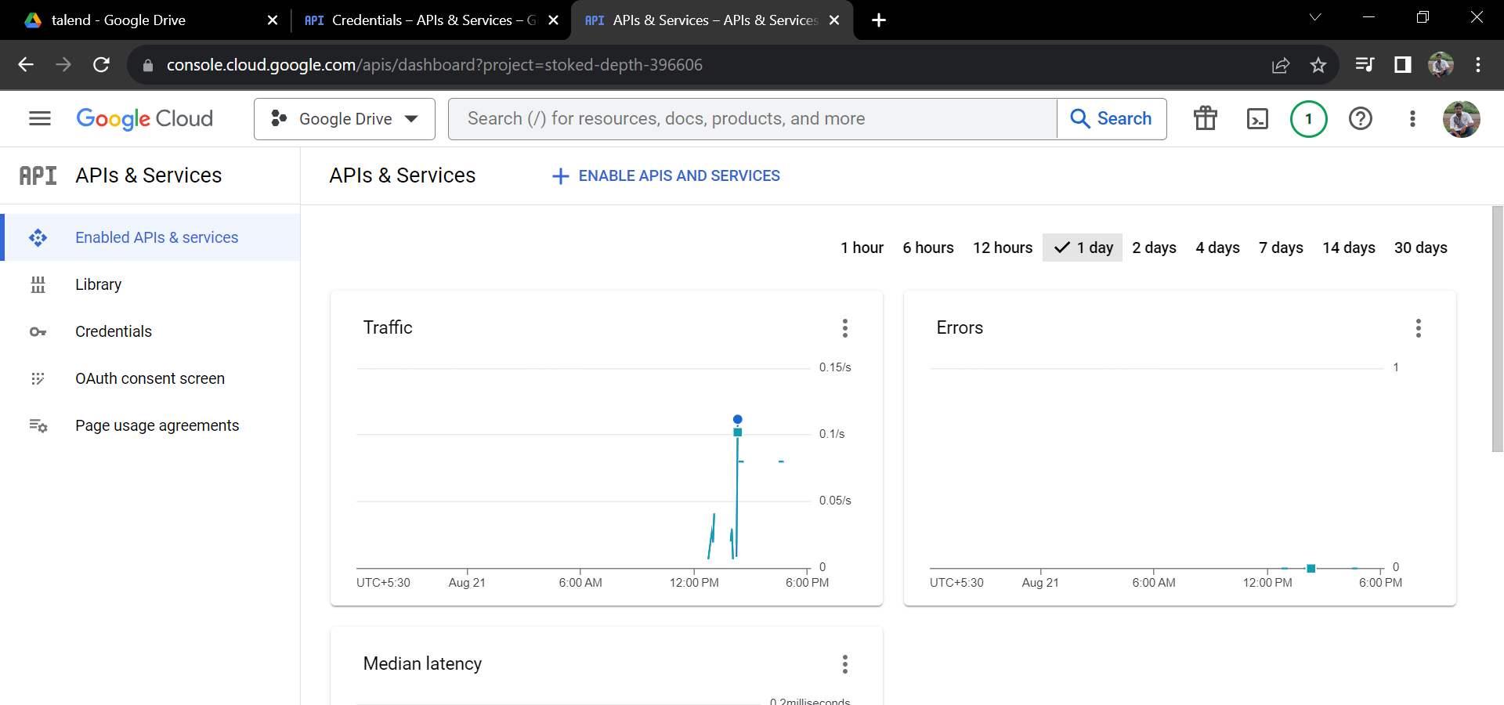

b:- Enable API and Services. Add Google Drive API.

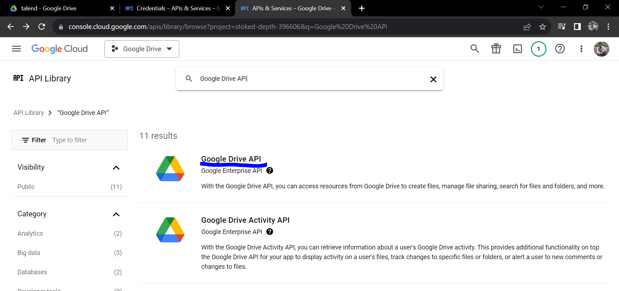

C:- Configure OAuth Consent Screen

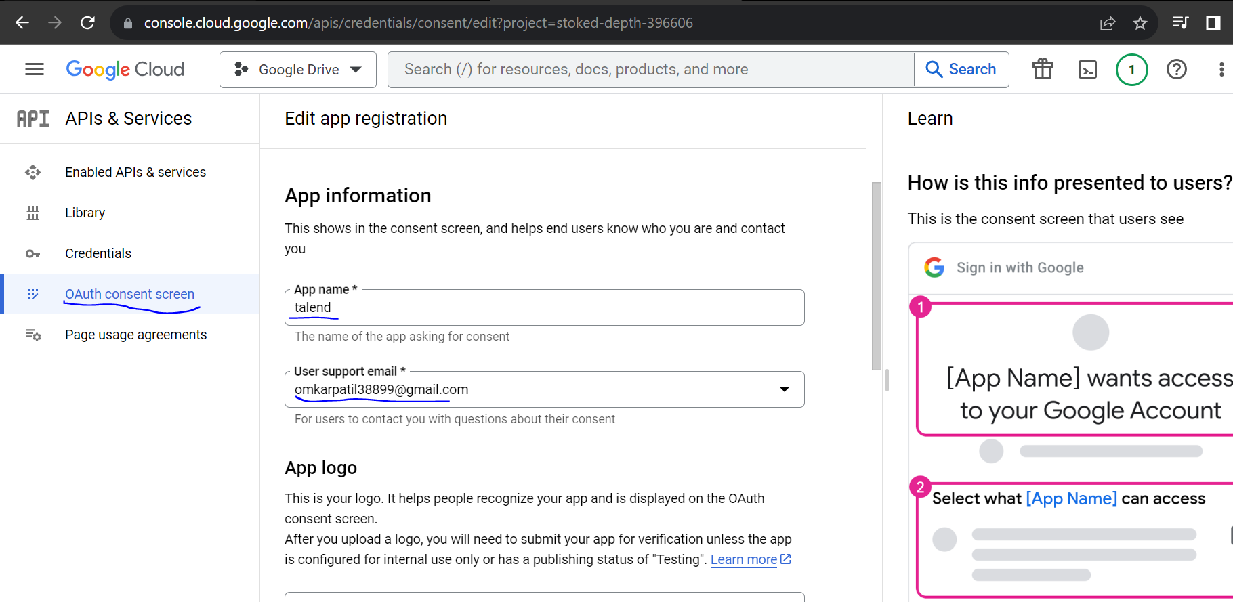

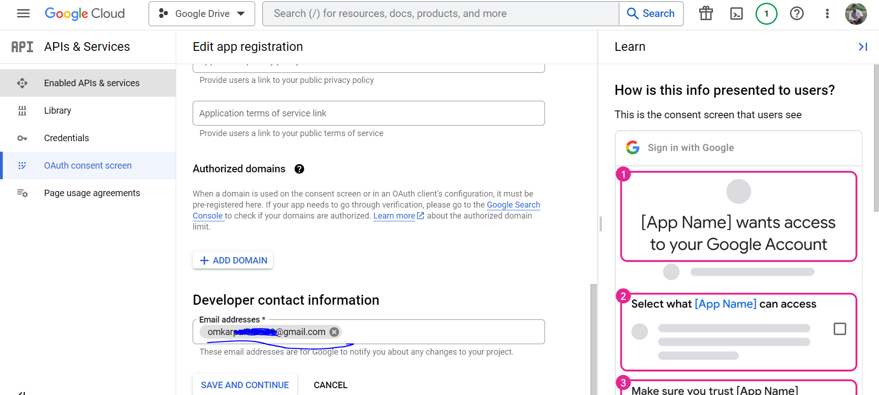

D:- Just Save and Continue and Complete all the Steps up to summary.

E:- Goto Credentials and click new project, and add the project.

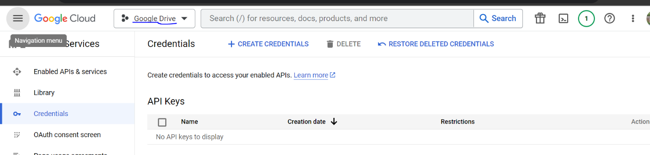

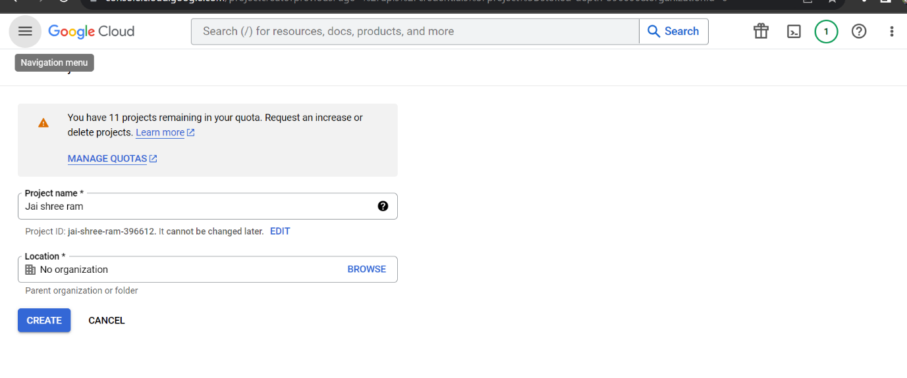

F:- Create the credentials

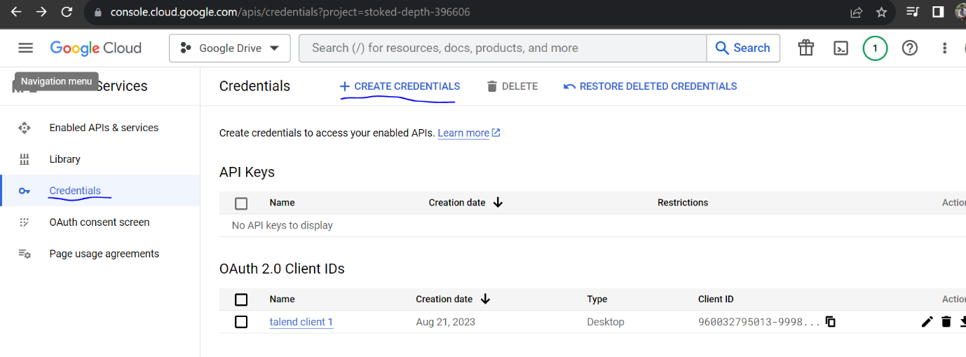

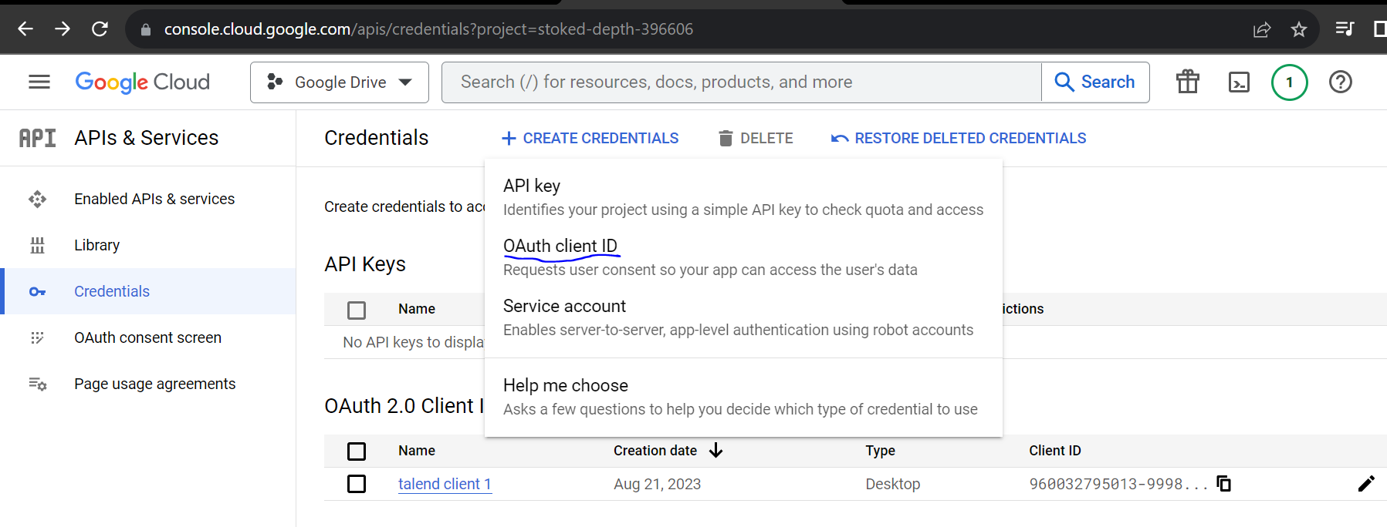

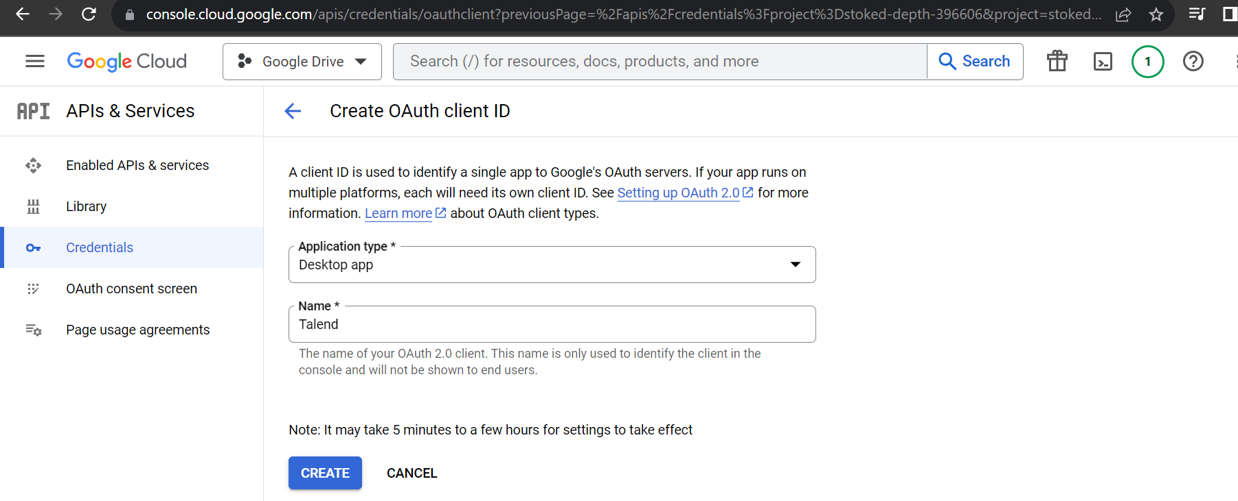

G:- Create the credentials and Save it. Or Download json file for login.

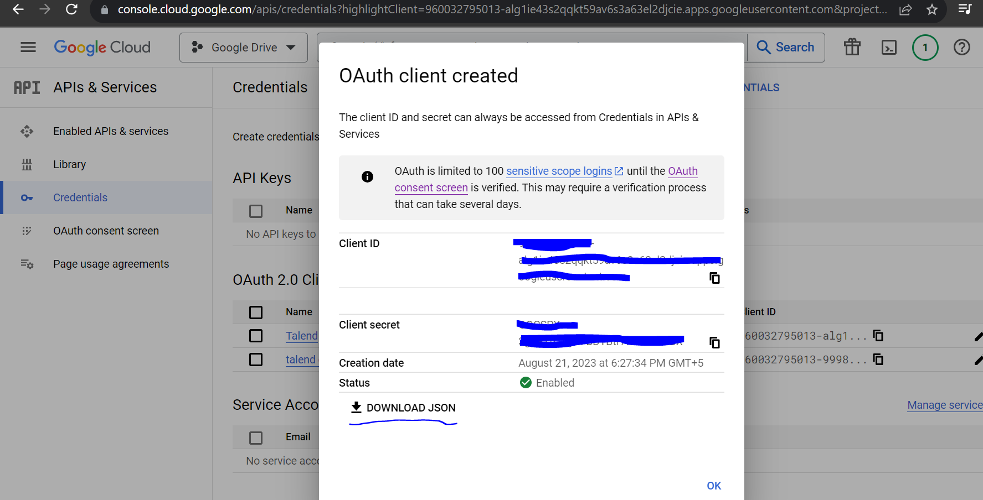

Step 3:- Open the Talend Studio. And create a job.

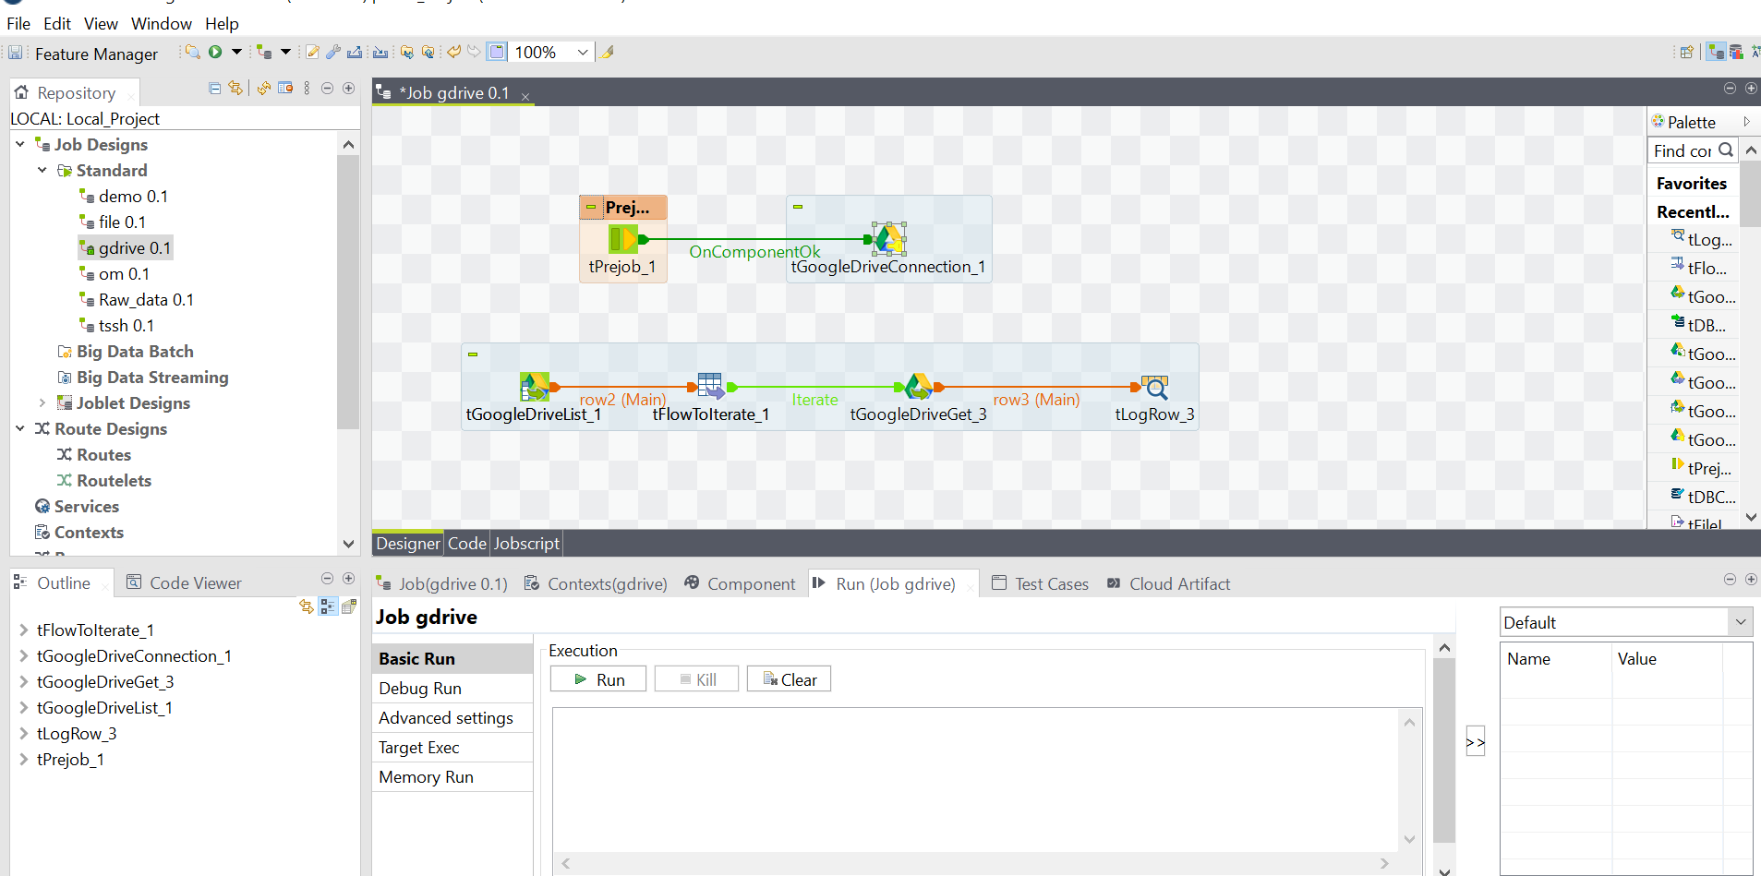

A:-Create the Google drive connection using “tGoogleDriveConnection”

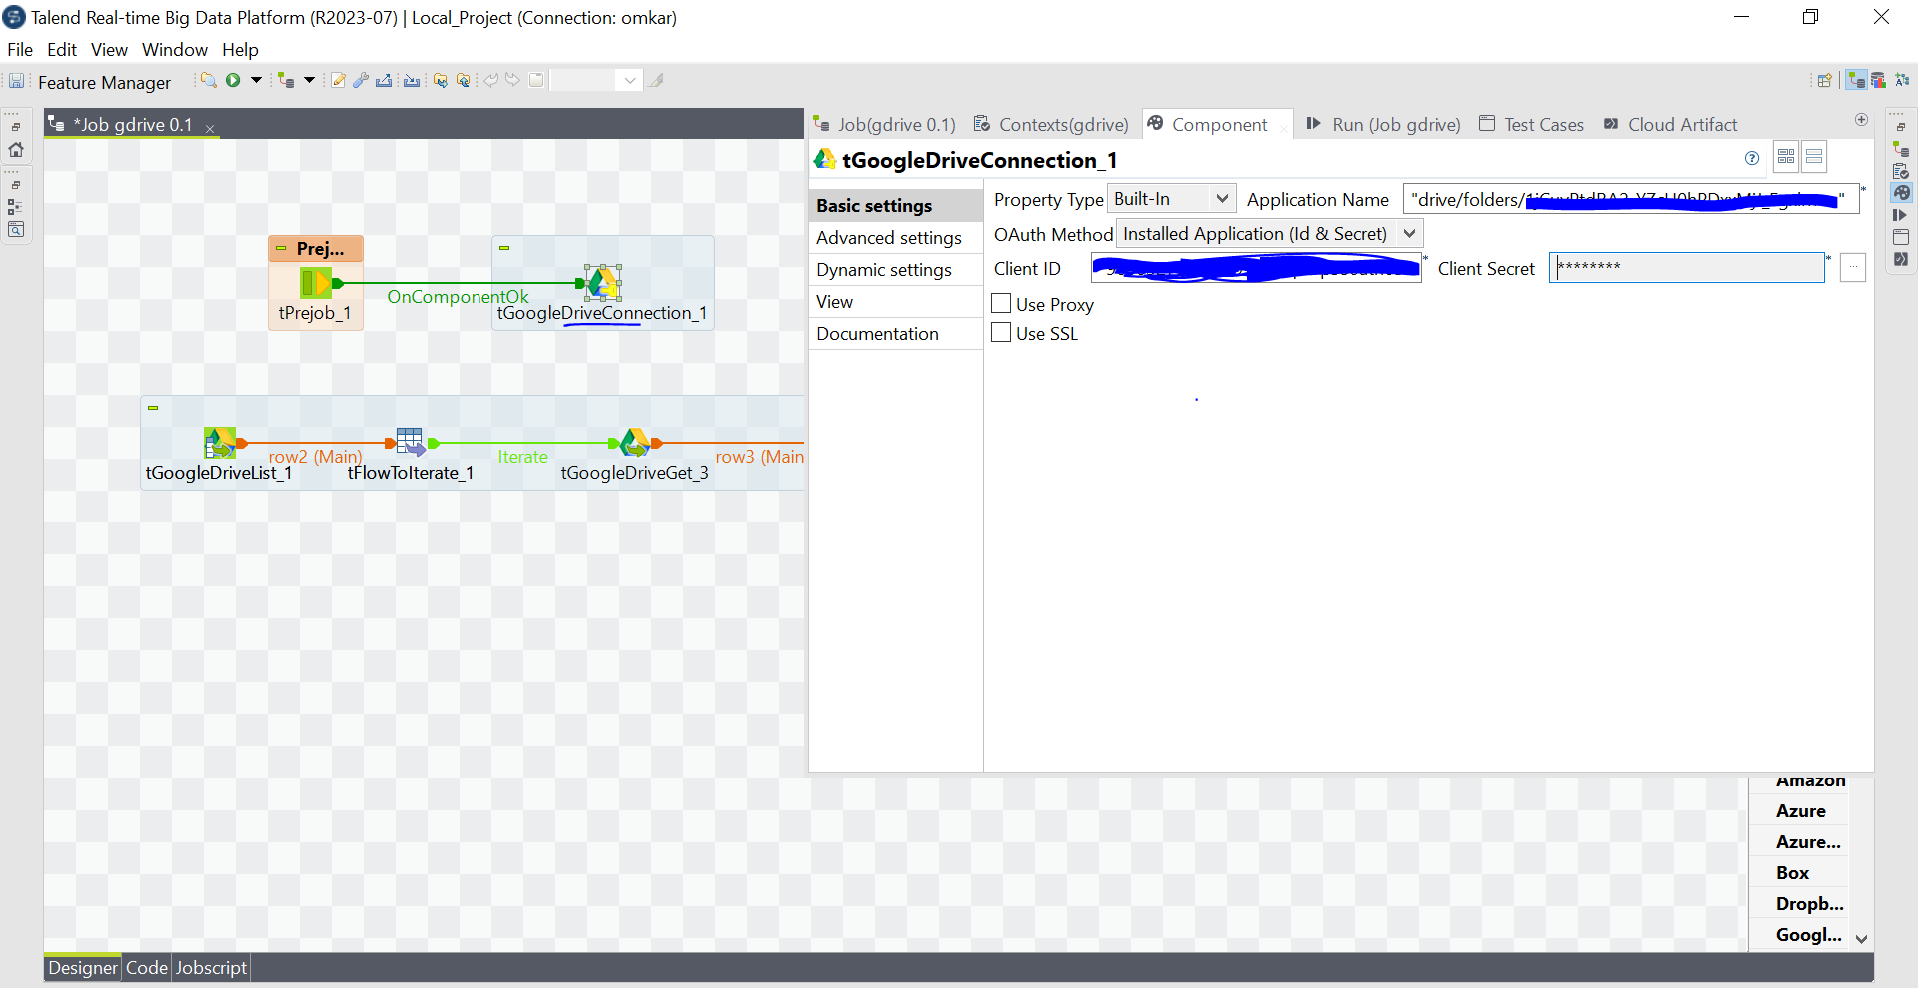

Provide the credentials which we created in the previous step for the following columns

ClienID:- “created client ID”

Client Secret:- “Created Client Secret”

Application Name:- “Path of Google drive folder”

B: For verification of the connection when we run the job, it navigates to the page below

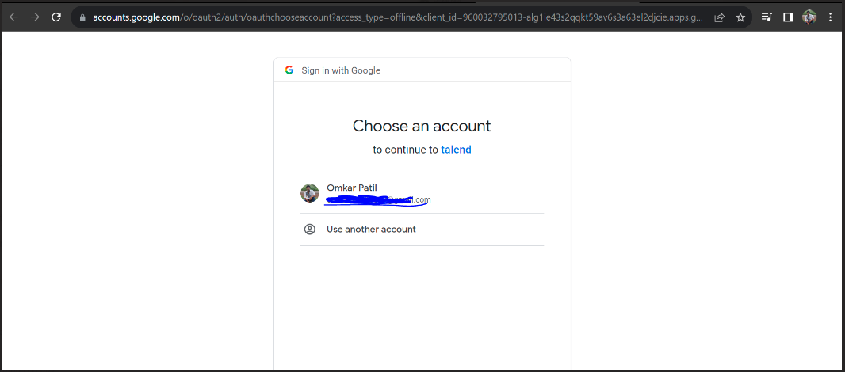

Here, we need to click on the email_id.

It will navigate to the page below

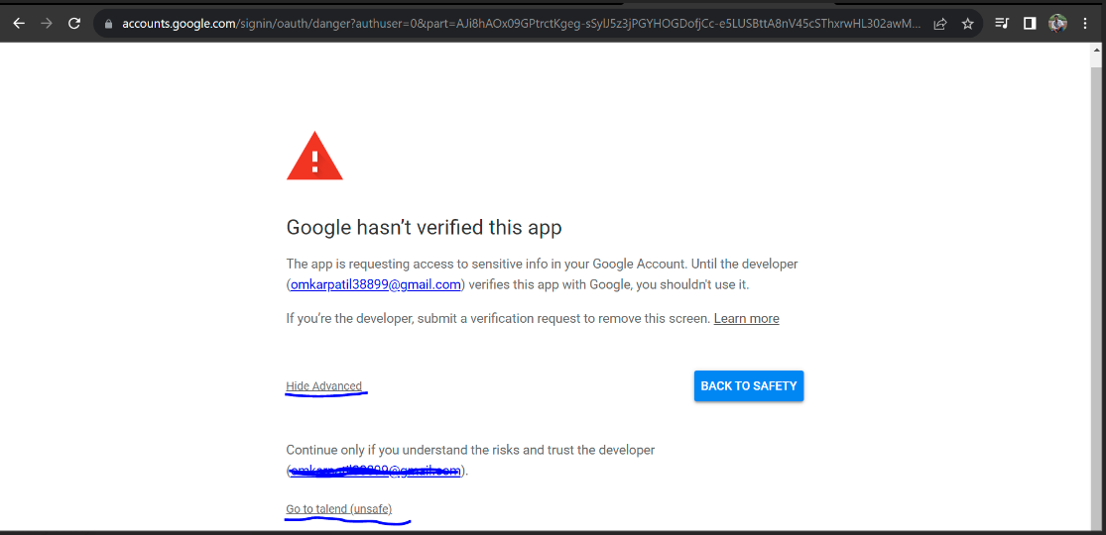

Here, we need to select **Hide Advanced** option, where we can see

**Go to Talend Console**

It will navigate to the next page

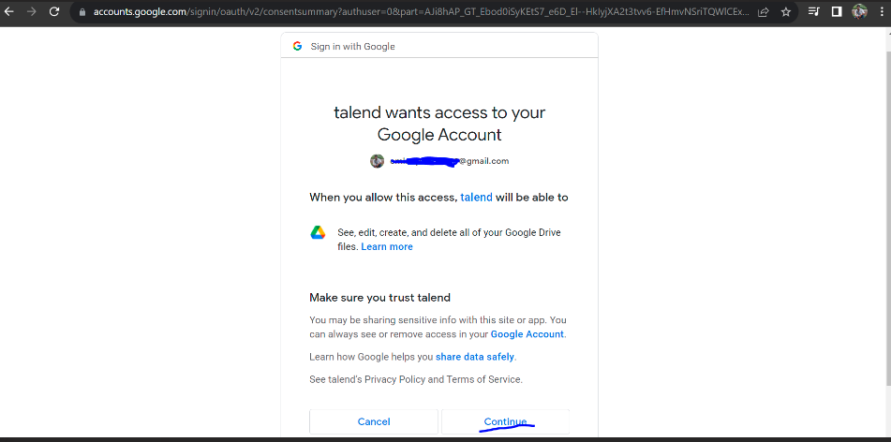

Here, we choose **continue**

Then we move to the next page

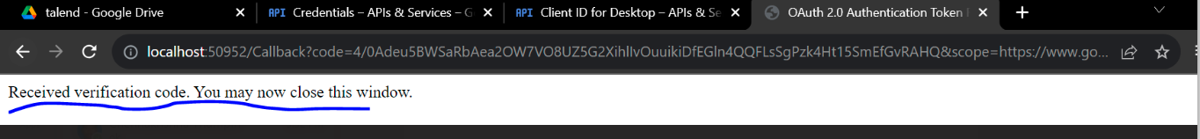

By this we close and we can access the data

C: -Use tGoogleDrive list to list all the files

Folder name: - “Give the folder name which we want to list”

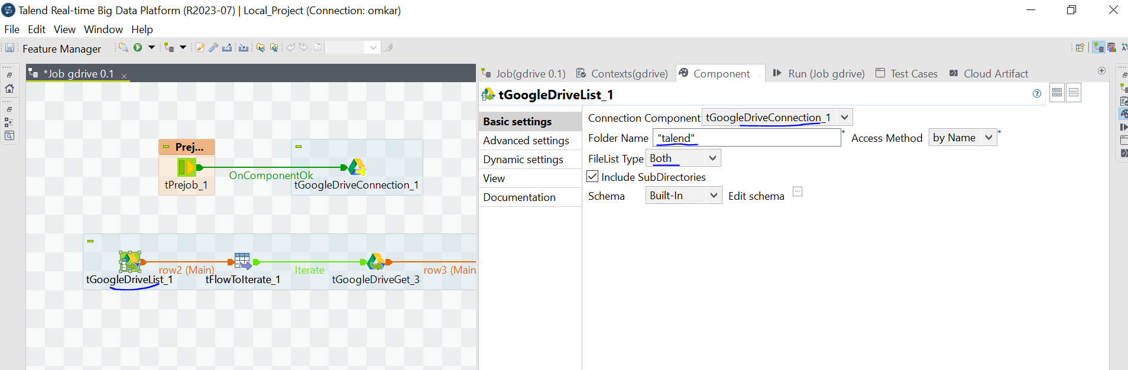

D:- Use TFlowToiterate (to iterate the list of the files present in the drive)

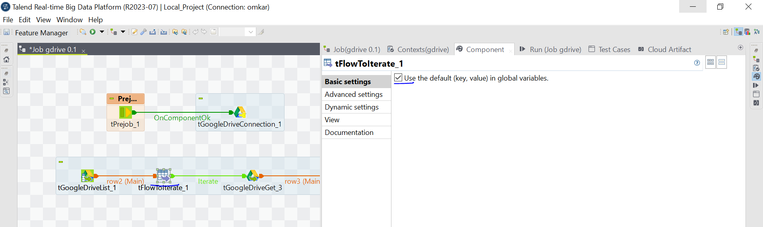

E:- use tGoogleDriveGet to Save the files in local Environment.

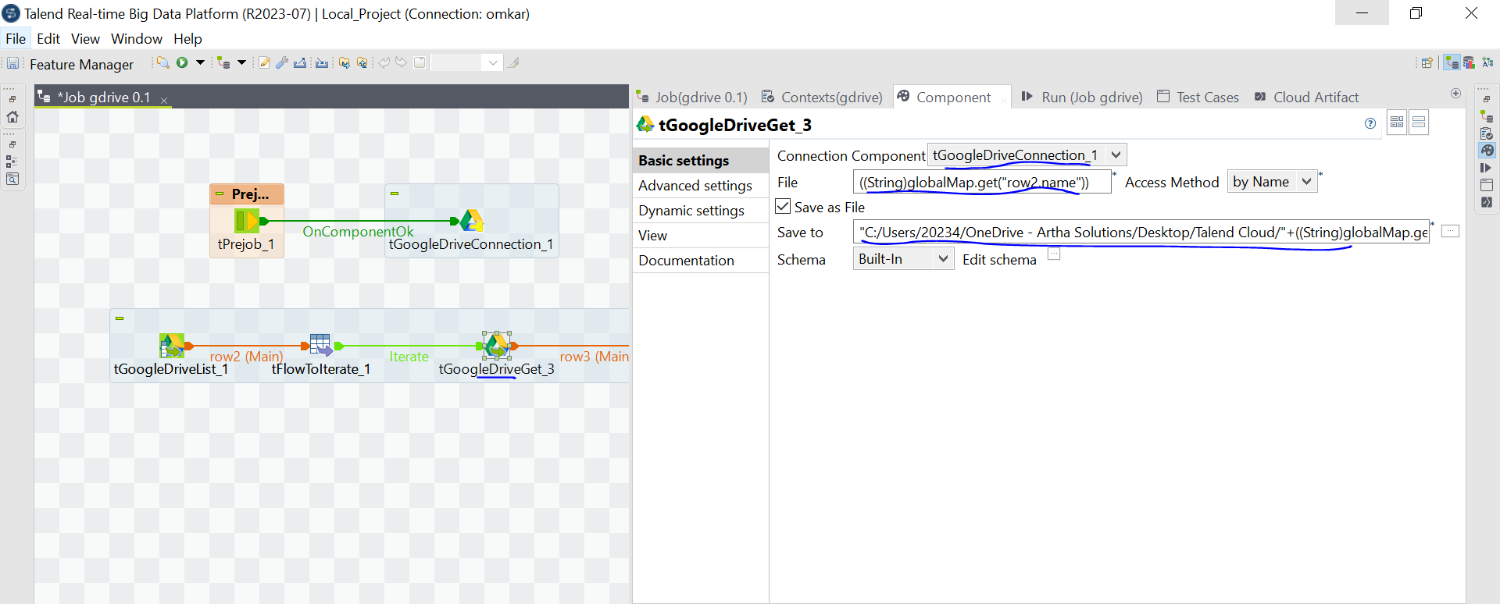

**File** : provide the global variable which is from the **tflowtoiterate** component

**Saveto** : provide the location of the file where we need to save

**Connection** component : we can use the existing connection which is created already in the first step